**Bansilal Ramnath Agarwal Charitable Trust’s**

**Vishwakarma Institute of Technology, Pune-37  *(An autonomous institute of Savitribai Phule Pune University)***



**Title : To identify Entity, Control, Boundary objects and trace object interactions for scenarios from use cases.**

|  |  |
| --- | --- |
| **Year** | **Third** |
| **Branch** | **AI & DS** |
| **Division** | **AI-A** |
| **Batch** | **3** |
| **PRN** | **12320092** |
| **Roll no.** | **81** |
| **Name** | **Pandit Manasi Dilip** |
| **Subject** | **Software Design and Methodologies** |

**1. System Scope**

The AR-powered treasure hunt game aims to revolutionize scavenger hunts by integrating augmented reality (AR) features that superimpose digital content onto physical environments. Players are guided through challenges requiring them to locate, scan, and interact with real-world objects enhanced by AR visuals. The platform is targeted at educational institutions, event organizers, and entertainment providers seeking innovative, location-based experiences.

**Key Features:**

* Customizable AR clues.
* Real-time scoring and leaderboards.
* Interactive maps highlighting player progress.
* Administrative tools for game creation and management.

**2. Actors**

Actors are entities that interact with the system. Based on the SRS document, the following actors can be identified:

1. **Players :** End-users participating in the treasure hunts. They interact with the mobile app to explore environments, solve puzzles, and track progress.
2. **Game Organizers :** Individuals or teams designing and managing games using the administrative web interface.
3. **System Administrators :** Professionals responsible for maintaining the system, ensuring data security, and handling updates.
4. **External Systems :** APIs and libraries like ARKit/ARCore for AR functionality, GPS for location tracking, and backend services for data synchronization.

**3. Use Cases**

Use cases describe the interactions between actors and the system to achieve specific goals. Below are the primary use cases:

**For Players:**

1. **Discover AR Clues :** Players use their device’s camera to scan the environment for hidden AR clues.
2. **Validate Clues :** Players scan objects to validate them as correct clues and earn points.
3. **View Interactive Maps** : Players access an interactive map showing their location and nearby clue zones.
4. **Track Progress :** Players view their scores and rankings on the leaderboard.

**For Game Organizers:**

1. **Create Games :** Organizers design games by setting AR overlays, time limits, and point values.
2. **Manage Games :** Organizers monitor player activities and update game settings in real-time.
3. **View Analytics :** Organizers analyze player performance and engagement metrics.

**For System Administrators:**

1. **Maintain System :** Administrators ensure smooth operation of the platform.
2. **Ensure Security :** Administrators implement data encryption and role-based access control.

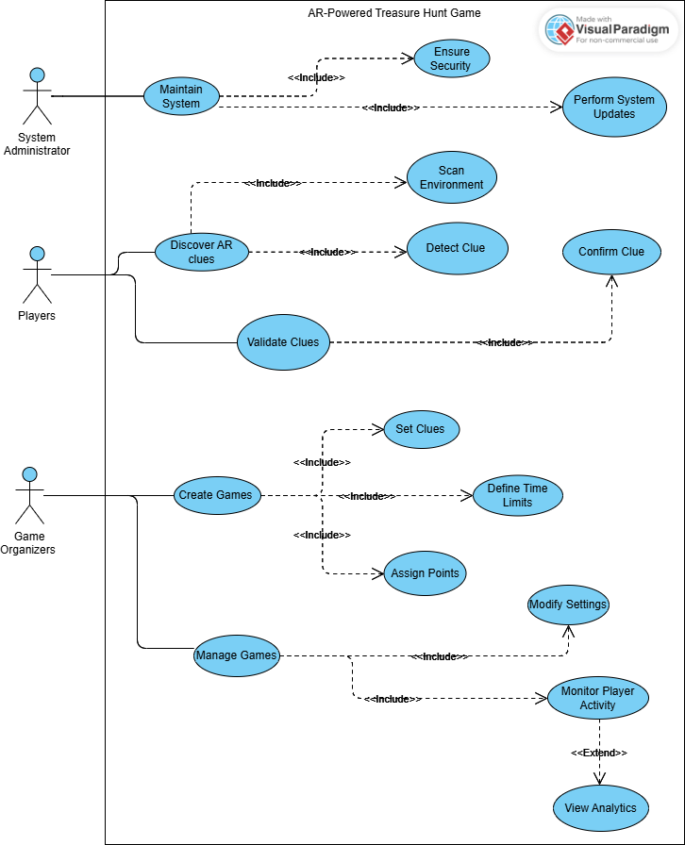



**Fig. Use Cases**

**Use Case Structuring**

We can organize the use cases into three main categories:

Main Use Case: Play Treasure Hunt Game

* Sub-Use Cases :
  + Discover AR Clues
  + Validate Clues
  + View Interactive Maps
  + Track Progress

Main Use Case: Manage Treasure Hunt Game

* Sub-Use Cases :
  + Create Games
  + Manage Games
  + View Analytics

Main Use Case: Maintain System

* Sub-Use Cases :
  + Ensure Security
  + Perform System Updates

**Use Case Narration**

Use Case Name : Discover AR Clues

Actor : Player

Preconditions :

* The player has installed and launched the app.
* Camera and location permissions are granted.

Postconditions :

* The player discovers an AR clue and receives feedback.

Normal Flow :

1. The player opens the AR scanner.
2. The system scans the environment using the camera.
3. A hidden AR clue is detected and displayed with visual effects.
4. The player interacts with the clue.

Alternate Flows :

* AF1: No Clue Found :
  + Message: "No clues found. Move to a new location."
  + Player moves and retries.
* AF2: Permission Denied :
  + Message: "Camera/location access required."
  + Player grants permissions in settings and retries.
* AF3: Poor Internet :
  + Warning: "Weak connection. Features may not work."
  + Player ensures a stable connection and resumes scanning.

**Conclusion**

The AR-powered treasure hunt game successfully integrates augmented reality to create an immersive and interactive experience for players. By identifying the system scope, actors, and use cases, the assignment effectively outlines the functional and non-functional requirements of the system. The use case structuring and narration provide a clear understanding of user interactions, ensuring a robust foundation for implementation. This project demonstrates the potential of AR technology in revolutionizing traditional scavenger hunts while catering to diverse stakeholders like players, organizers, and administrators.